

**SINGLE CODE BASE LIBRARY MANAGEMENT SYSTEM**

**A MINI - PROJECT REPORT**

***Submitted by***

**ANANDHARAMAN P 820318104005**

**NIGASH V 820318104022**

**VISHAL KUMARAN D 820318104043**

**BACHELOR OF ENGINEERING**

**in**

**COMPUTER SCIENCE AND ENGINEERING**

**A.V.C. COLLEGE OF ENGINEERING, MAYILADUTHURAI**

**MANNAMPANDAL - 609305**

**ANNA UNIVERSITY, CHENNAI – 600025**

**JUNE 2021**

**ANNA UNIVERSITY: CHENNAI 600 025**

**BONAFIDE CERTIFICATE**

Certified that this mini-project report **“SINGLE CODE BASE LIBRARY MANAGEMENT SYSTEM”** is the bonafide work of **P. ANANDHARAMAN (820318104005), V. NIGASH (820318104022), D. VISHAL KUMARAN (820318104043)** who carried out their Mini-Project work during the academic year **2020-2021.**

**GUIDE HOD**

**EXAMINED ON:**

**INTERNAL EXAMINER EXTERNAL EXAMINER**

**ACKNOWLEDGEMENT**

The success and final outcome of this project required a lot of guidance and assistance from many people and we are extremely fortunate to have got this all along the completion of my project work. Whatever we have done is only due to such guidance and assistance and we extend our deep gratitude to our Management. We are sincerely obliged to our respected Principal **Dr. C. SUNDAR RAJ, Ph.D.,** who has always been a constant source of inspiration.

We express our respectful thanks to **Dr. S. PadmaPriya, Ph.D.,** the Professor and Head of our Department for her kind and mutual aid to complete our project.

We are thankful to and fortunate enough to get constant encouragement, support and guidance from **Dr. K. Krishnakumari, Ph.D.,** Guide for this Mini Project work of our department. Also, we would like to extend our sincere regards to all the **Teaching and Non-Teaching staffs** of our department for their timely support.

Finally, we express our heartfelt gratitude to our **Parents and Friends** who had encouraged us in successful completion of our project and people who have willingly helped us out with their abilities.

**TABLE OF CONTENTS**

|  |  |  |
| --- | --- | --- |
| **CHAPTER NO** | **TITLE** | **PAGE NO** |
|  | **ABSTRACT** | 6 |
|  | **LIST OF FIGURES** | 7 |
|  | **LIST OF TABLES** | 7 |
| **1** | **INTRODUCTION** | 8 |
|  | * 1. Library Management | 8 |
|  | 1.2 Existing System | 8 |
|  | * 1. Proposed system | 9 |
|  | 1.4 Web frame work-Laravel | 9 |
|  | 1.4.1 Laravel Framework Features | 9 |
|  | 1.5 Mobile app frame work-Flutter | 10 |
|  | 1.5.1 Flutter Features | 10 |
|  | 1.6 Database-MySQL | 10 |
|  | 1.7 Version Control System-Git | 11 |
|  | 1.8 Hosting-Heroku | 11 |
| **2** | **LITERATURE SURVEY** | 12 |
| **3** | **SYSTEM SPECIFICATION** | 13 |
|  | 3.1 Hardware Requirements | 13 |
|  | 3.2 Software Requirements | 13 |
| **4** | **ANALYSIS OF THE PROJECT** | 14 |
|  | 4.1 Architecture | 14 |
|  | 4.2 Use case scenario | 15 |
|  | 4.3 Classes of Library Management System | 17 |
|  | 4.4 Attributes of Library Management System | 18 |
|  | 4.5 Methods of Library Management System | 18 |
| **5** | **SYSTEM DESIGN** | 19 |
|  | 5.1 Application Interface | 19 |
|  | 5.2 Admin Registration/Login | 19 |
|  | 5.3 Student/Staff Registration | 19 |
|  | 5.4 Search Book | 19 |
|  | 5.5 Admin Module | 20 |
| **6** | **IMPLEMENTATION** | 20 |
|  | 6.1 Web Application | 21 |
|  | 6.2 Android Application | 21 |
|  | 6.3 iOS Application | 21 |
| **7** | **SOFTWARE TESTING**  7.1Test case scenario | 22 |
|  | 7.2 Manual Testing | 22 |
| **8** | **RESULTS AND DISCUSSION** | 24 |
| **9** | **CONCLUSION AND FUTURE ENHANCEMENT** | 30 |
|  | 9.1 Conclusion | 33 |
|  | 9.2 Future Enhancement | 33 |
|  | **REFERENCES** | 34 |

**ABSTRACT**

Online Library Management System is a system which maintains the information about the books present in the library, their authors, the members of library to whom books are issued, library staff and all. This is very difficult to organize manually. Maintenance of all this information manually is a very complex task. Owing to the advancement of technology, organization of an Online Library becomes much simple. The Online Library Management has been designed to computerize and automate the operations performed over the information about the members, book issues and returns and all other operations. This computerization of library helps in many instances of its maintenances. It reduces the workload of management as most of the manual work done is reduced. The entire proposed system is ready to be used by college and it is going to have iOS, android, and web application in single code base.

**KEYWORDS:** Online Library Management, computerization of library, Single codebase.

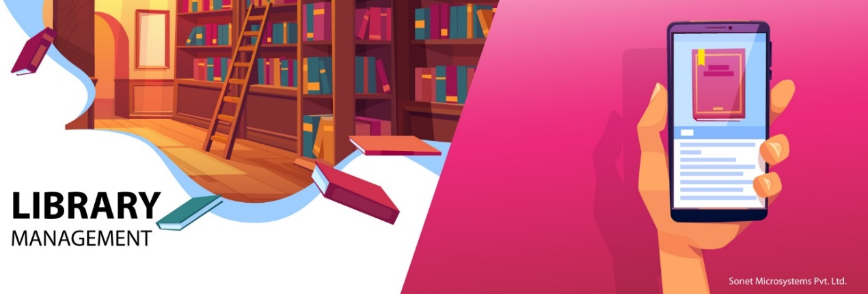

**LIST OF FIGURES**

|  |  |  |
| --- | --- | --- |
| **Figure No** | **Figure Name** | **Page No** |
| Fig 4.1 | Use case diagram | 15 |
| Fig 4.2 | Class diagram | 17 |
| Fig 8.1 | Landing Page (Home Page) | 23 |
| Fig 8.2 | Librarian/Admin Registration page | 23 |
| Fig 8.3 | Student / Staff Registration Page | 24 |
| Fig 8.4 | Search Book Page | 24 |
| Fig 8.5 | Librarian/admin Landing page | 25 |
| Fig 8.6 | All Waiting Students page | 25 |
| Fig 8.7 | All Approved Students | 26 |
| Fig 8.8 | All Books in Library Page | 26 |
| Fig 8.9 | Add Book Publication Page | 27 |
| Fig 8.10 | Add Books Page | 27 |
| Fig 8.11 | Add Settings page | 28 |
| Fig 8.12 | Issue Book/Return Book page | 28 |
| Fig 8.13 | All Issued Book Page | 29 |
| Fig 8.14  Fig 8.15  Fig 8.16  Fig 8.17 | Database  Mobile App Icon  Mobile App Loading Screen  Mobile Application | 29  30  30  31 |

**LIST OF TABLES**

|  |  |  |
| --- | --- | --- |
| **Table no** | **Table name** | **Page no** |
| Table 7.1 | Test Results | 22 |

**CHAPTER 1**

**INTRODUCTION**

* 1. **LIBRARY MANAGEMENT**

A Library management system is a software that uses to maintain the record of the library. It contains work like the number of available books in the library, the number of books are issued or returning or renewing a book or late fine charge record, etc. Library Management Systems is software that helps to maintain a database that is useful to enter new books & record books borrowed by the members, with the respective submission dates. Moreover, it also reduces the manual record burden of the librarian. Library management system allows the librarian to maintain library resources in a more operative manner that will help to save their time. It is also convenient for the librarian to manage the process of books allotting and making payment. Library management system is also useful for students as well as a librarian to keep the constant track of the availability of all books in a store

* 1. **EXISTING SYSTEM**

The current Library Management System does not eliminate the process of searching books within the library campus. Students have to find books manually. The admin personal also have to look manually on which day which person will take the charge within library to manage the overall work maintenance of library catalogue and arrangement of the books to the catalogue is very complex task. In addition to its maintenance of member details, issue dates and return dates etc. manually is a complex task. All the operations must be performed in perfect manner for the maintenance.

* 1. **PROPOSED SYSTEM**

The online Library Management System come with all the basic as well as some innovative features for managing a library. It consists of a large database of various books available in the library. It also lists various books issued to respective readers. The system keeps track of all the books readily available and also the books that have been issued to various readers for the time period for which the books have been issued. The system also handles books database. Readers usually tend to forget the date to return their library books, so this system even calculates fine depending on the expiry date. Thus, this innovative library management system provides enhanced library functionality for this modern world.

* 1.  **WEB FRAME WORK-LARAVEL**

Laravel is a web application framework with expressive, elegant syntax. A web framework provides a structure and starting point for creating your application, allowing you to focus on creating something amazing while we sweat the details. Laravel strives to provide an amazing developer experience, while providing powerful features such as thorough dependency injection, an expressive database abstraction layer, queues and scheduled jobs, unit and integration testing, and more.

**1.4.1 Laravel Framework Features**

Laravel support MVC architecture pattern and this framework is highly acknowledged for its built-in lightweight templates, Laravel provides you with an Eloquent object-relational mapping, Laravel framework provides a solid web app security. Laravel migration system helps to expand the structure of the database of the web application.

**1.5 MOBILE APP FRAME WORK-FLUTTER**



Flutter is Google’s open source technology for creating mobile, desktop, and web apps with a single codebase. Unlike other popular solutions, Flutter is not a framework or library; it’s a complete SDK – software development kit. Let’s briefly clarify it here to make sure we’re on the same page. A library is basically a reusable piece of code that you put in your application to perform a certain common function. A framework is a structure that provides you with a skeleton architecture for building software. It’s a set of tools that serves as a foundation for your app, requiring you to fill in the blanks with your code to complete the entire structure and get the desired functionality.

**1.5.1 FLUTTER FEATURES**

### Fast Development

Paint your app to life in milliseconds with Stateful Hot Reload. Use rich

set of fully-customizable widgets to build native interfaces in minutes.

### Expressive and Flexible UI

Quickly ship features with a focus on native end-user experiences. Layered

architecture allows for full customization, which results in incredibly fast

rendering and expressive and flexible designs.

### Native Performance

Flutter’s widgets incorporate all critical platform differences such as

scrolling, navigation, icons and fonts, and your Flutter code is compiled to

native ARM machine code using [Dart's native compilers](https://dart.dev/platforms).

**1.6** **MySQL**

MySQL Database Service is a fully managed database service to deploy cloud-native applications.

**1.7 VERSION CONTROL SYSTEM-GIT**



Git is a [free and open source](https://git-scm.com/about/free-and-open-source) distributed version control system designed to handle everything from small to very large projects with speed and efficiency. Git is [easy to learn](https://git-scm.com/doc) and has a [tiny footprint with lightning fast performance](https://git-scm.com/about/small-and-fast). It outclasses SCM tools like Subversion, CVS, Perforce, and Clear Case with features like [cheap local branching](https://git-scm.com/about/branching-and-merging), convenient [staging areas](https://git-scm.com/about/staging-area), and [multiple workflows](https://git-scm.com/about/distributed).

**1.8 HOSTING- HEROKU**



Heroku is a container-based cloud Platform as a Service (PaaS). Developers use Heroku to deploy, manage, and scale modern apps. Our platform is elegant, flexible, and easy to use, offering developers the simplest path to getting their apps to market. Heroku is fully managed, giving developers the freedom to focus on their core product without the distraction of maintaining servers, hardware, or infrastructure. The Heroku experience provides services, tools, workflows, and polyglot support all designed to enhance developer productivity.

**CHAPTER 2**

**LITERATURE SURVEY**

A Library Management System is a tool to help any libraries which are still using the old way to manage their library. The old way like searching for a book using manual work is hassle, fast report generation is not possible, information about issue/return of the books are not properly maintained, no central database can be created as information is not available in database. But by using the LMS, user can overcome all the problems mentioned above. This system can manage all the happenings of the library. Book transactions including book searching, availability of the book, details and appearance of the book, personal book borrowing history and etc. can be very easily handled by this system. This system is suitable for small to big libraries including medical and legal libraries, colleges, schools, universities, corporate houses and other academic resource centres. However, I would like to focus on LMS for colleges or universities.

LMS has three modules which are Students Module, Staff Module, and Administration Module. First of all, Students Module allows students to search material by title, name/author, subject, publication, series, and etc. it also allow students to find recently arrived material. In Staff Module, staff can issue book and receive book with bar code. Staff also can fine for books received after due date. Lastly, the administration module help administrator to register/reassign shelf and category, change book status, issue library card, configuration to register users, and database backup/restore. Overall this system can be very helpful and it can make things easier.

As the economic growth increased the peoples are led to the higher aspiration to excel in education and work through better access to information and knowledge. Technologies for building user-centered digital library environments and making computer-user interactions more intelligent should be explored. Earnshaw discussed in his article about the old libraries and its drawbacks to keeping records. A book provided an irreducible deposit of information that could be read, reviewed, criticized, as well as providing the basis for the development of its ideas into further volumes. Information is no longer exclusively library-centric but is also network-centric.

**CHAPTER 3**

**SYSTEM SPECIFICATION**

**3.1 HARDWARE REQUIREMENTS**

* CPU type : Intel Core i5
* Clock speed :3.0 GHz
* RAM size :8 GB
* Hard disk (SSD) :500 GB

**3.2 SOFTWARE REQUIREMENTS**

* Operating System : Windows 10
* IDE : Visual Studio Code, Android Studio
* Language : HTML, CSS, PHP, JAVASCRIPT,

DART, YAML, XML, SWIFT, MYSQL.

* Version Control System: Git
* Hosting : Heroku

**CHAPTER 4**

**ANALYSIS OF THE PROJECT**

**4.1 ARCHITECTURE**

The Library Management System using the Laravel framework is a web-based application that points in building up an automated Integrated library system to keep up all day-by-day work of the library. This undertaking has numerous highlights that are commonly not accessible in typical integrated library system, facilities like separate user interfaces for different users having different priorities. It also has a facility of admin login. Through this, the admin can monitor the whole system. In this system, users can see the list of books they have taken and its issue date, return date and also, they can reserve the books online. The fine count is robotized with exactness. The application is to assist clients in maintaining and organizing the library. It is easy to use for both beginners and advanced users. It incorporates a recognizable, well-thoroughly considered, and appealing UI joined with solid searching, insertion and. Generally, this of our own is being created to help students as well as the staff to keep up the library in the most ideal manner conceivable and decrease human endeavors, also entire proposed system is ready to be used by college and it is going to have iOS, android, and web application in single code base.

**Fig 4.1 Use Case Diagram**

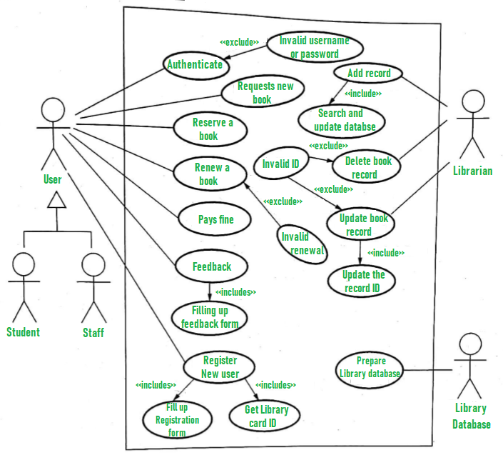

**4.2 USE CASE SCENARIOS OF THE SYSTEM**

1. User who registers himself as a new user initially is regarded as staff or student for the library system.
   * For the user to get registered as a new user, registration forms are available that is needed to be fulfilled by the user.
   * After registration, a library card is issued to the user by the librarian. On the library card, an ID is assigned to cardholder or user.
2. After getting the library card, a new book is requested by the user as per there requirement.
3. After, requesting, the desired book or the requested book is reserved by the user that means no other user can request for that book.
4. Now, the user can renew a book that means the user can get a new due date for the desired book if the user has renewed them.
5. If the user somehow forgets to return the book before the due date, then the user pays fine. Or if the user forgets to renew the book till the due date, then the book will be overdue and the user pays fine.
6. User can fill the feedback form available if they want to.
7. Librarian has a key role in this system. Librarian adds the records in the library database about each student or user every time issuing the book or returning the book, or paying fine.
8. Librarian also deletes the record of a particular student if the student leaves the college or passed out from the college. If the book no longer exists in the library, then the record of the particular book is also deleted.
9. Updating database is the important role of Librarian.

**Fig 4.2 Class Diagram**

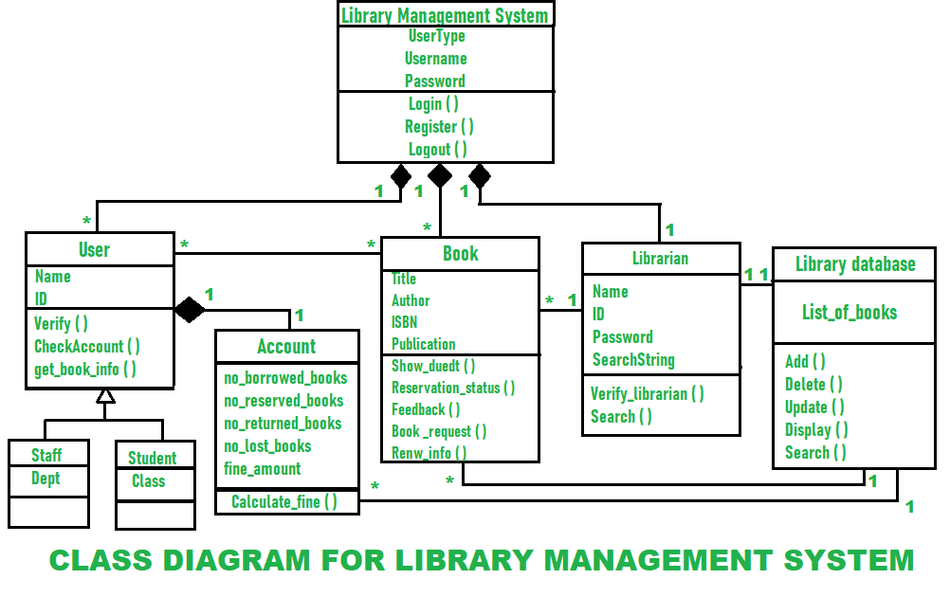

**4.3 Classes of Library Management System:**

* **Library Management System class –**It manages all operations of Library Management System. It is central part of organization for which software is being designed.
* **User Class –**Tt manages all operations of user.
* **Librarian Class –** It manages all operations of Librarian.
* **Book Class –**It manages all operations of books. It is basic building block of system.
* **Account Class –**It manages all operations of account.
* **Library database Class –**It manages all operations of library database.
* **Staff Class –**It manages all operations of staff.
* **Student Class –**It manages all operations of student.

**4.4 Attributes of Library Management System:**

* **Library Management System Attributes –**User Type, Username, Password
* **User Attributes –**Name, Id
* **Librarian Attributes –**, Id, Password, Search String
* **Book Attributes –**Title, Author, ISBN, Publication
* **Account Attributes –**no_borrowed_books, no_reserved_books, no_returned_books, no_lost_books fine amount
* **Library database Attributes –**List_of_books
* **Staff Class Attributes –**Dept
* **Student Class Attributes –**Class

**4.5 Methods of Library Management System:**

* **Library Management System Methods –**  
  (), Register(), Logout()
* **User Methods –**Verify (), CheckAccount (), get_book_info ()
* **Librarian Methods –**Verify_librarian (), Search ()
* **Book Methods –**Show_duedt (), Reservation_status (), Feedback (), Book_request (), Renew_info ()
* **Library database Methods –**Add (), Delete (), Update (), Display (), Search ()

**CHAPTER 5**

**SYSTEM DESIGN**

The modules involved in the project are as follows

* Application Interface
* Admin Registration/Login
* Student/Staff Registration
* Search Book
* Admin Module

**5.1 Application Interface**

Application interface is the graphical user interface module of the overall system. It consists of Librarian/admin login and registration tab and student registration and Book search Tab as the landing page for the Application

**5.2Admin Registration/Login**

Using this module, the authority of the library can create their own login credentials with an ease of access, the librarian can sign out and sign in everywhere with a pc or in mobile app.

**5.3 Student/staff Registration**

Using This module, the end user (student/staff) can register to the library to confirm their entry to the system, their request is only approved by the librarian/admin, the student/staff can access the library when registration and approval is completed.

**5.4 Search Book**

Most scalable feature without registration login everyone can see the list of books in the library with all the details of the book

**5.5 Librarian/Admin Module**

The Librarian/admin has the following functionalities in the system- Login, Registration, Add Book Publication, Add Books in Library and Details, View Issued Books, All Waiting Students, All Approved Students, Add Settings, Issue/Return Books.

**CHAPTER 6**

**IMPLEMENTATION**

The system can be accessed by a computer or by a smart phone (android and iOS) for the librarian/admin for fast & easy management of all the library details

**6.1 Web Application**

-Primary application built using Laravel Framework with Front end-HTML CSS & Back end-php, MySQL JavaScript online application, most efficient fast and easy User interface quick response working system.

**6.2 Android Application**



**-** Secondary application with all the same features of Web application, Compact user friendly and used by the critical times when a computer is not available

**6.3 iOS Application**

**-** Secondary iOS application with all the same features of Web application, Compact user friendly and used by the critical times when a computer is not available

**CHAPTER 7**

**SOFTWARE TESTING**

**7.1 TEST CASE SCENARIO**

In This Online library management system, each and every tab is tested manually to ensure the working of each module, In the test case scenario, the cases are derived to ensure that all statements in the program have been executed at least once during testing and all logical conditions have been executed. It executes all the loops at their boundaries and within their operational bounds. If the test result is pass, the testing is done successfully else the process is repeated until we get the result is pass.

**7.2 MANUAL TESTING**

**Table 7.1 Test Results**

|  |  |  |  |  |
| --- | --- | --- | --- | --- |
| **NO** | **TEST CASE SCENARIO** | **EXPECTED RESULT** | **TEST RESULT** | **TEST ANALYSIS** |
| 1 | Landing Page for web/Loading page for App | Display successful Admin Reg/Login tab Student/staff Reg, book search | Application Connected and Displayed successfully | PASS |
| 2 | Admin Registration and login | Display Successful registration and login | Login/reg Successful | PASS |
| 3 | Student/Staff Registration | Display Successful registration | Successfully registered | PASS |
| 4 | Book search | Displayed the searched book | Displayed the book successful | PASS |
| 5 | Database connection | Connected Successfully | Connected  successfully | PASS |
| 6 | Approve waiting Students and see approved students | Whole list of students | Successfully displayed the waiting and approved students | PASS |
| 7 | Add books, publication, settings and view issued books | Display of Books, publication option and settings | Successfully displayed | PASS |

**CHAPTER 8**

**RESULTS AND DISCUSSION**

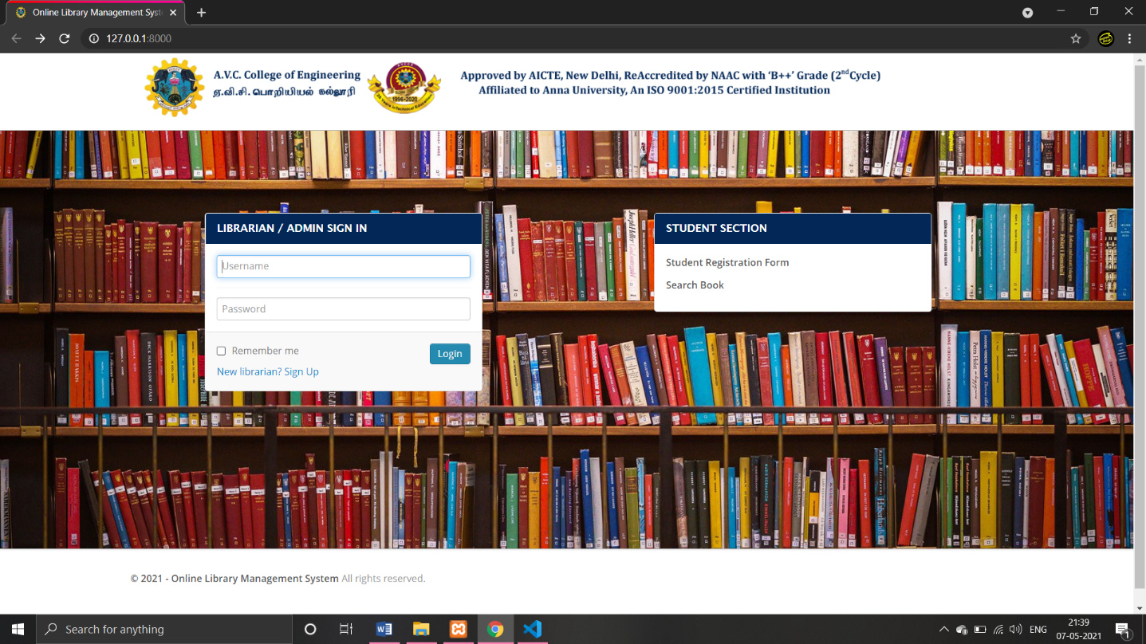**Fig 8.1 Landing Page (Home Page)**

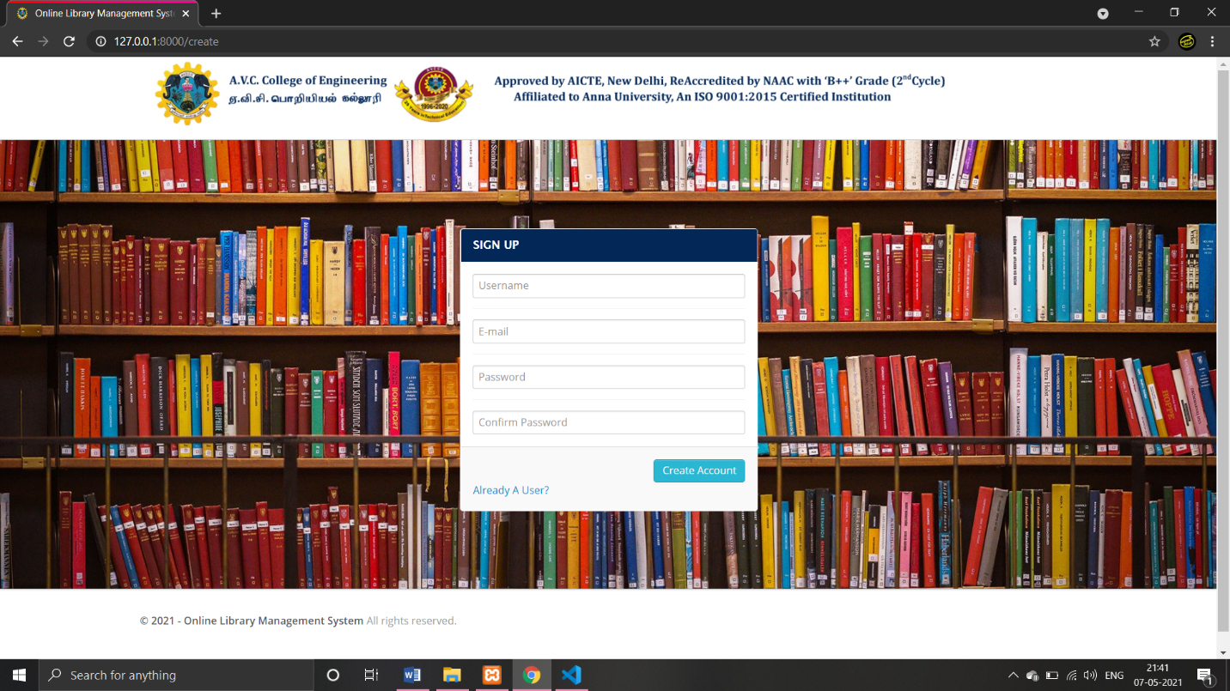**Fig 8.2 Librarian/Admin Registration page**

**Fig 8.3 Student / Staff Registration Page**

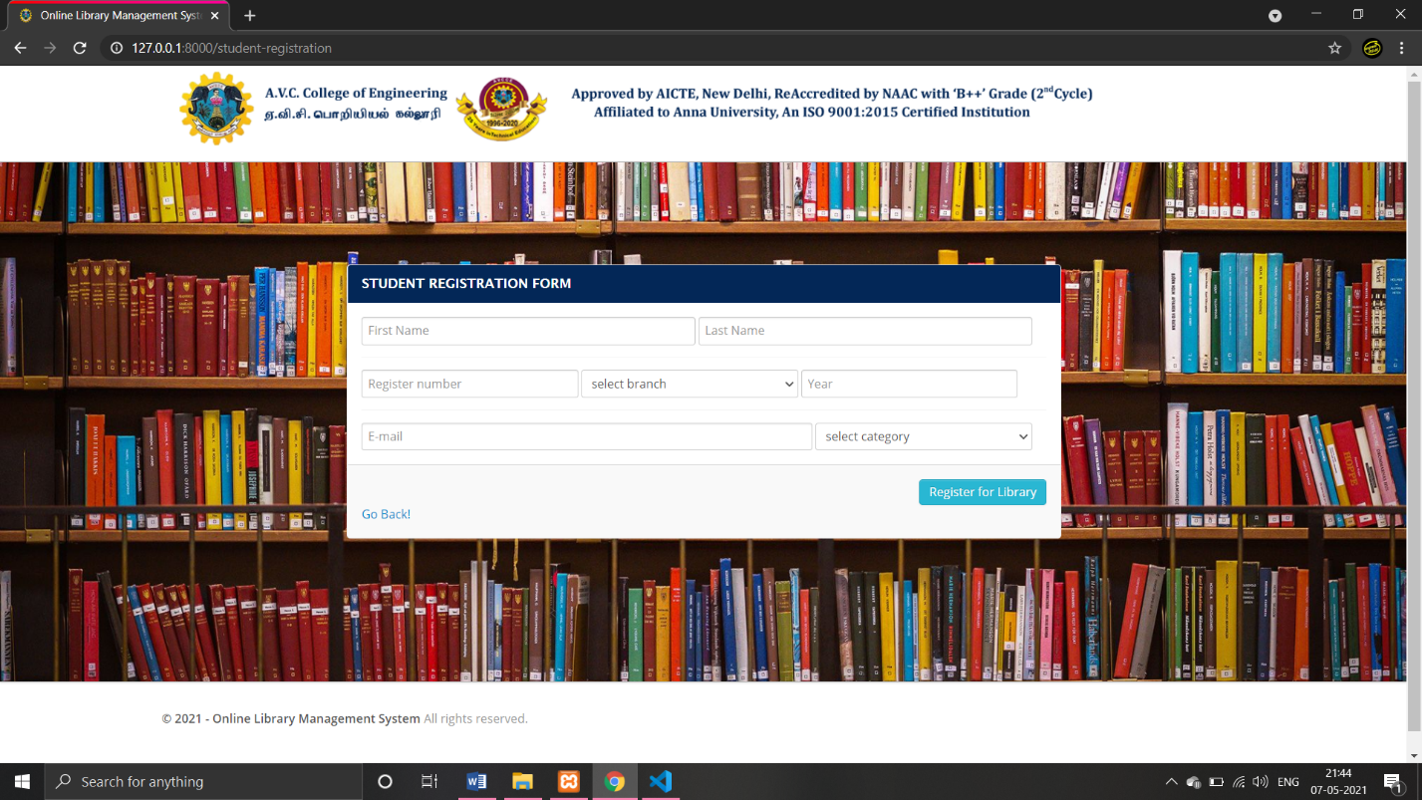

**Fig 8.4 Search Book Page**

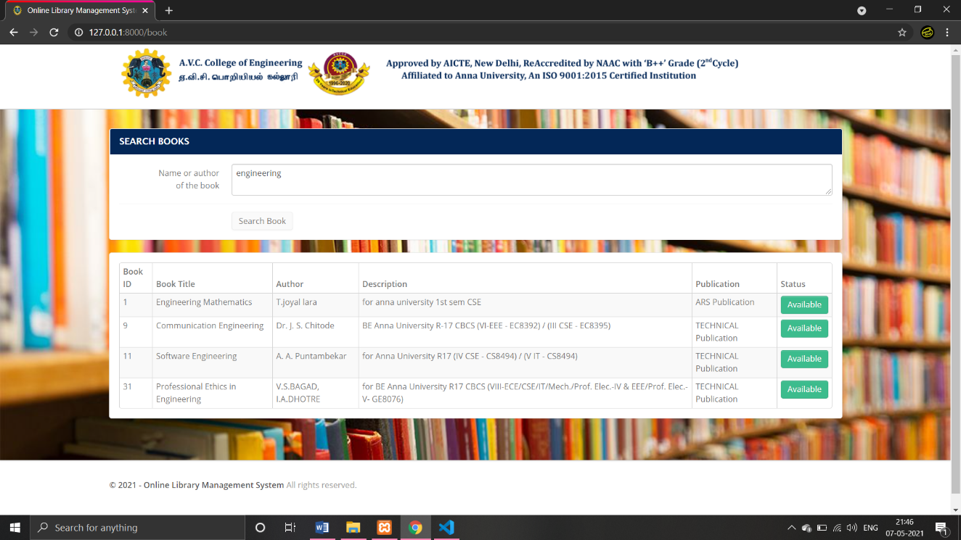

**Fig 8.5 Librarian/admin Landing page**

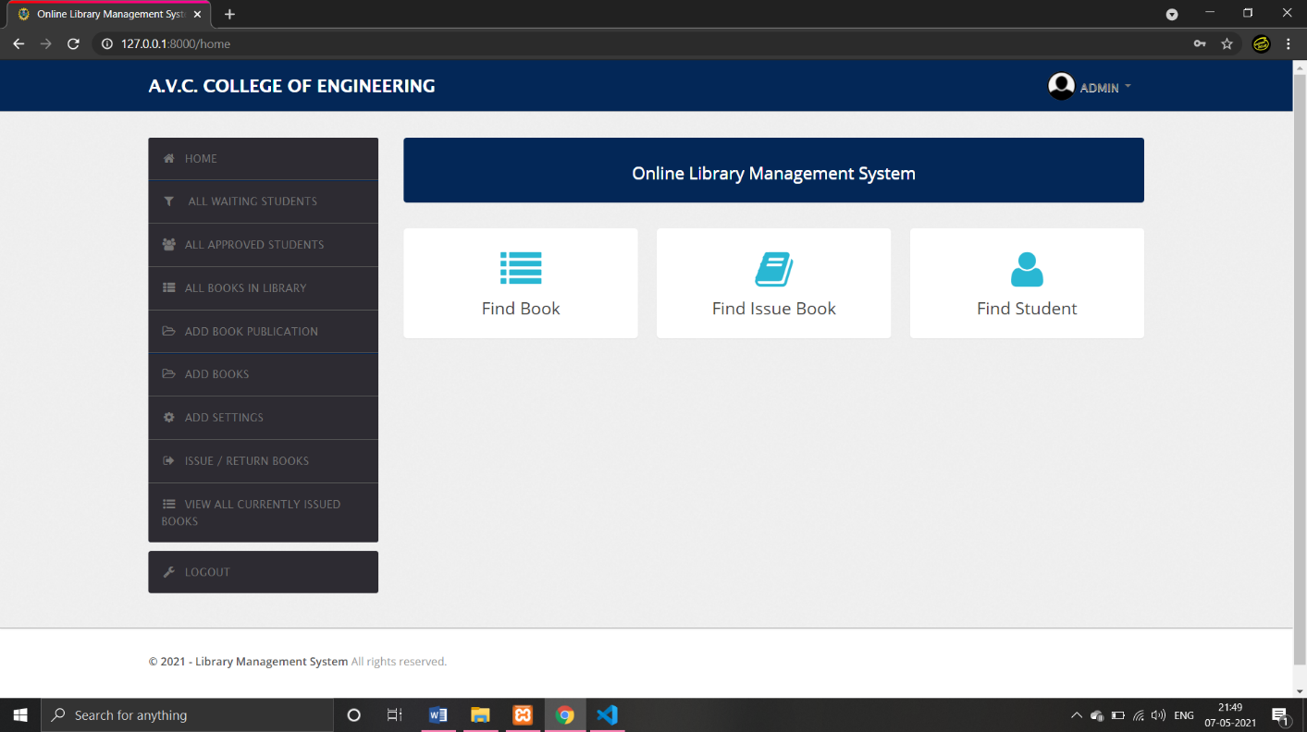

**Fig 8.6 All Waiting Students page**

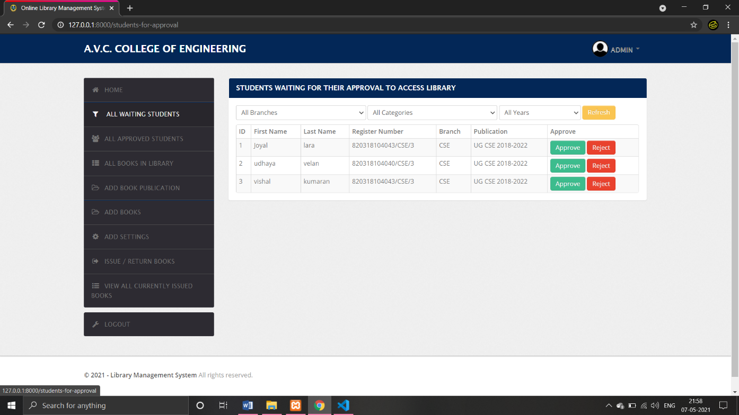

**Fig 8.7 All Approved Students**

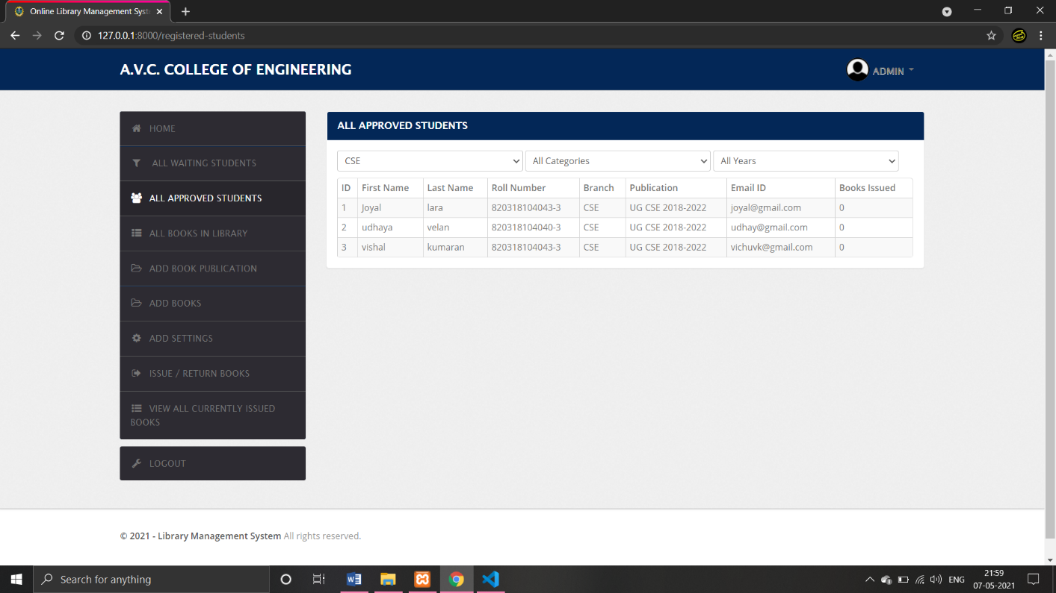

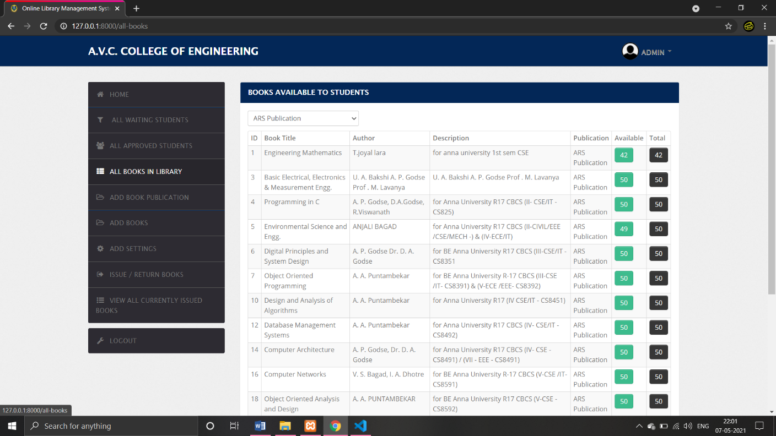**Fig 8.8 All Books in Library Page**

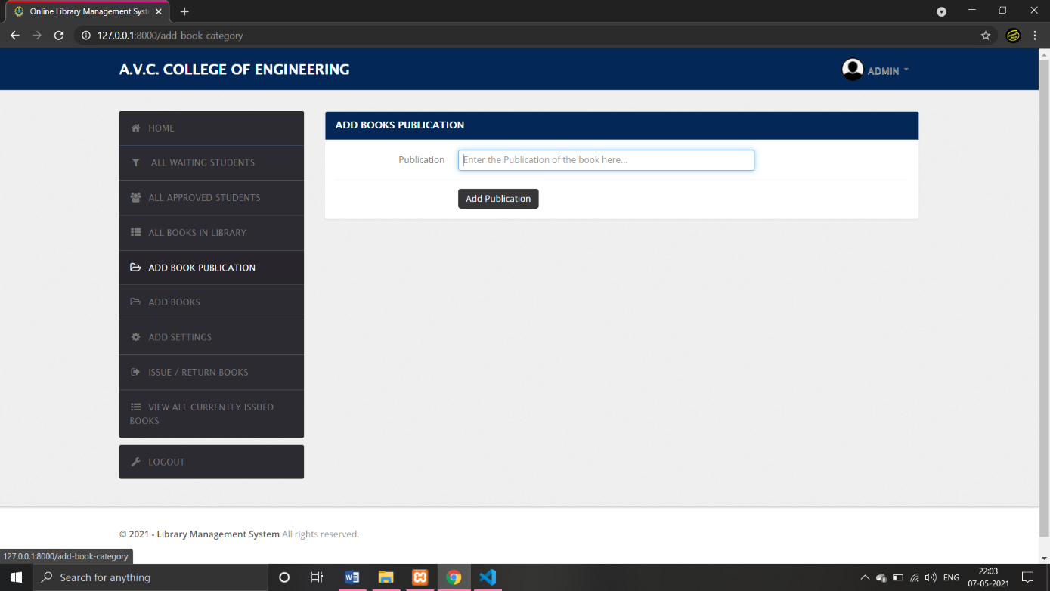**Fig 8.9 Add Book Publication Page**

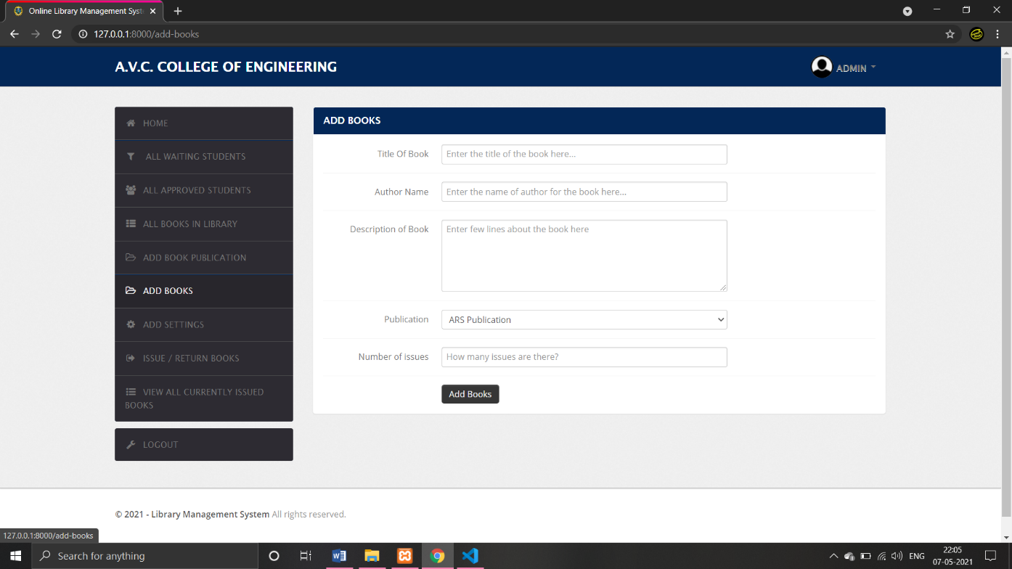**Fig 8.10 Add Books Page**

**Fig 8.11 Add Settings page**

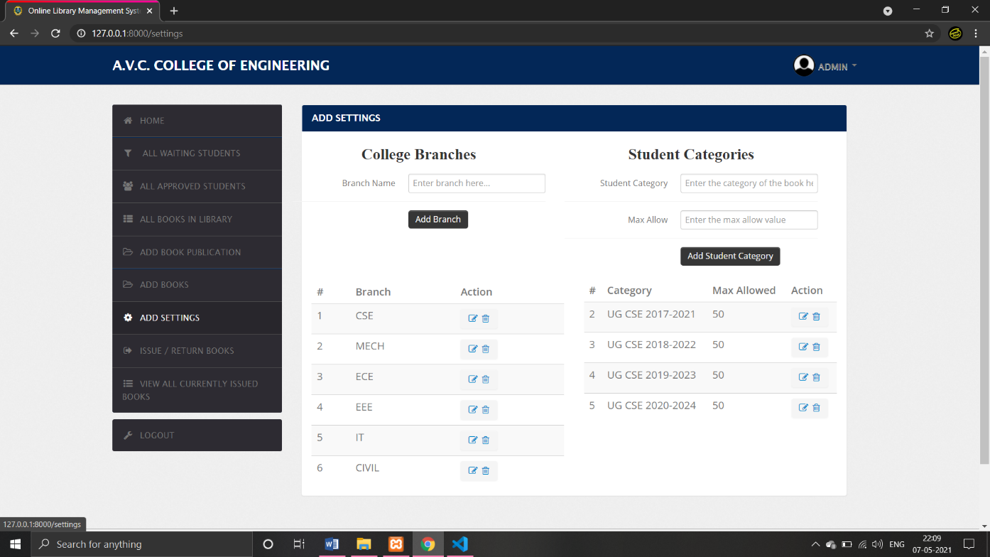

**Fig 8.12 Issue Book/Return Book page**

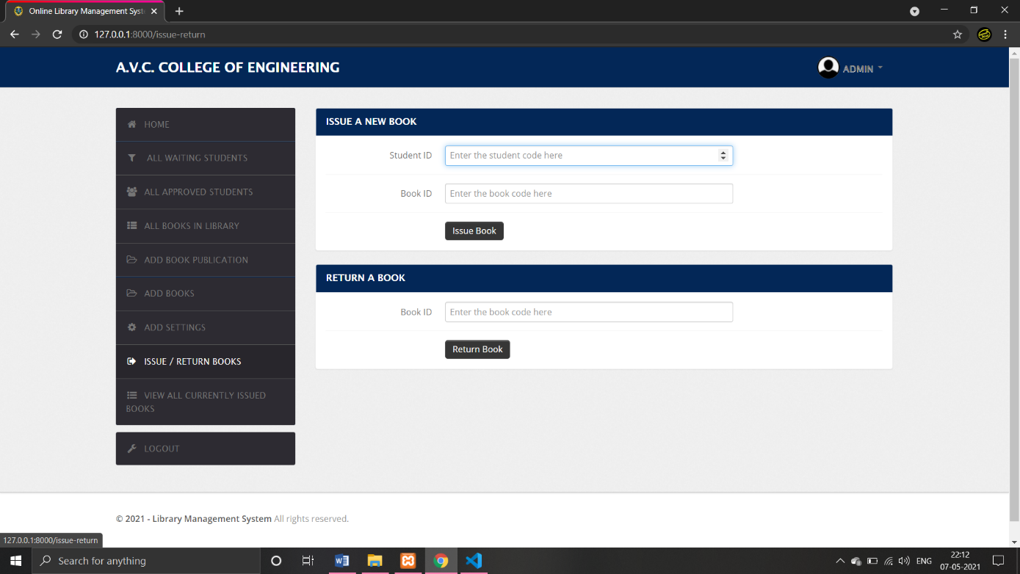

**Fig 8.13 All Issued Book Page**

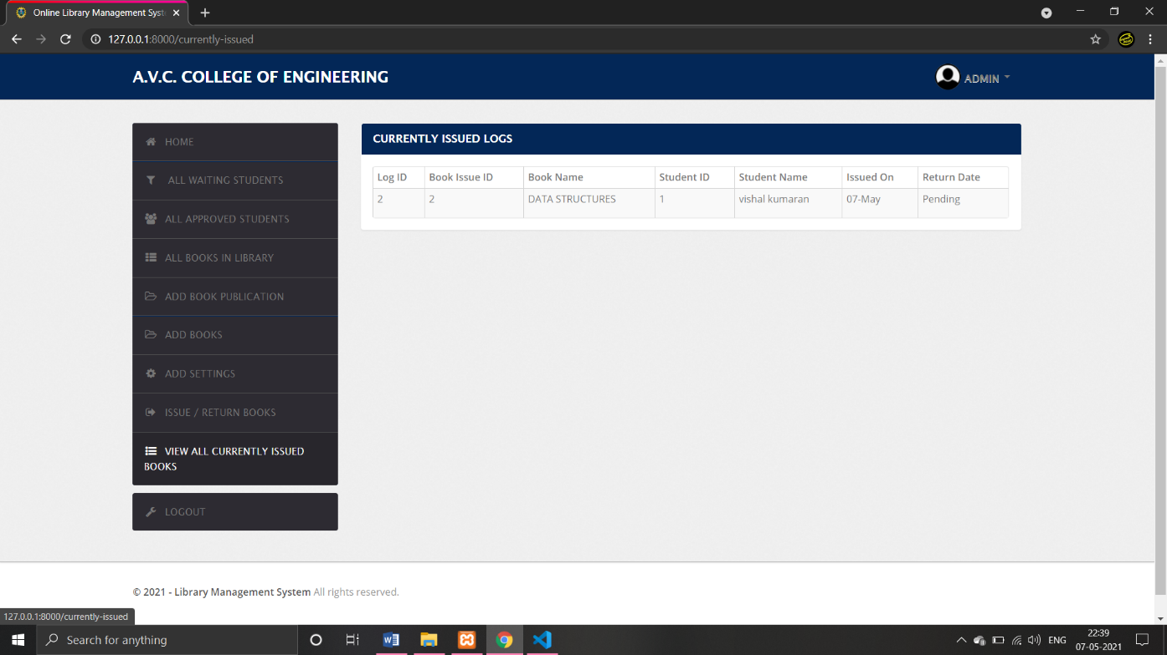

**Fig 8.14 Database**

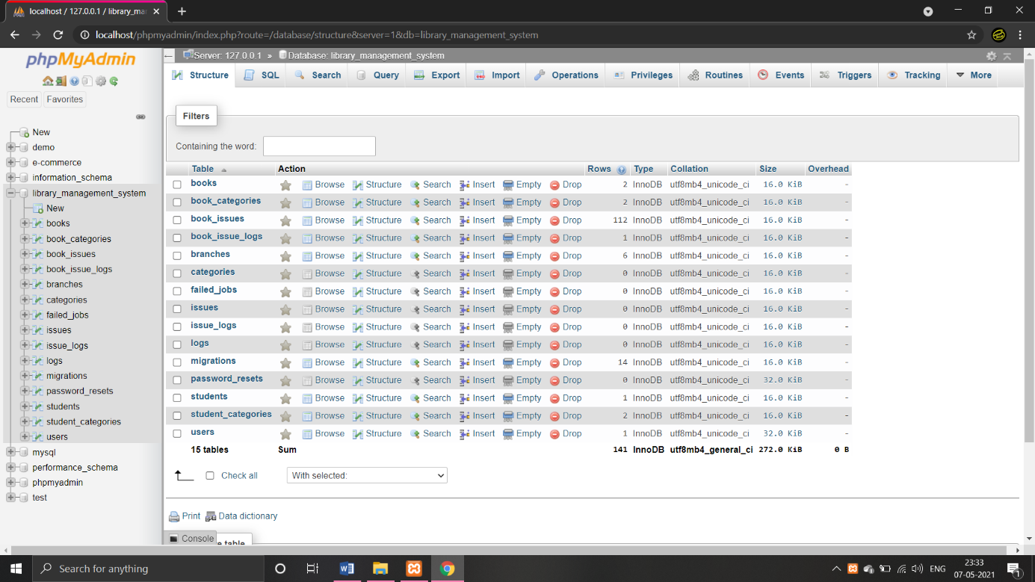

**Fig 8.15 Mobile app icon**

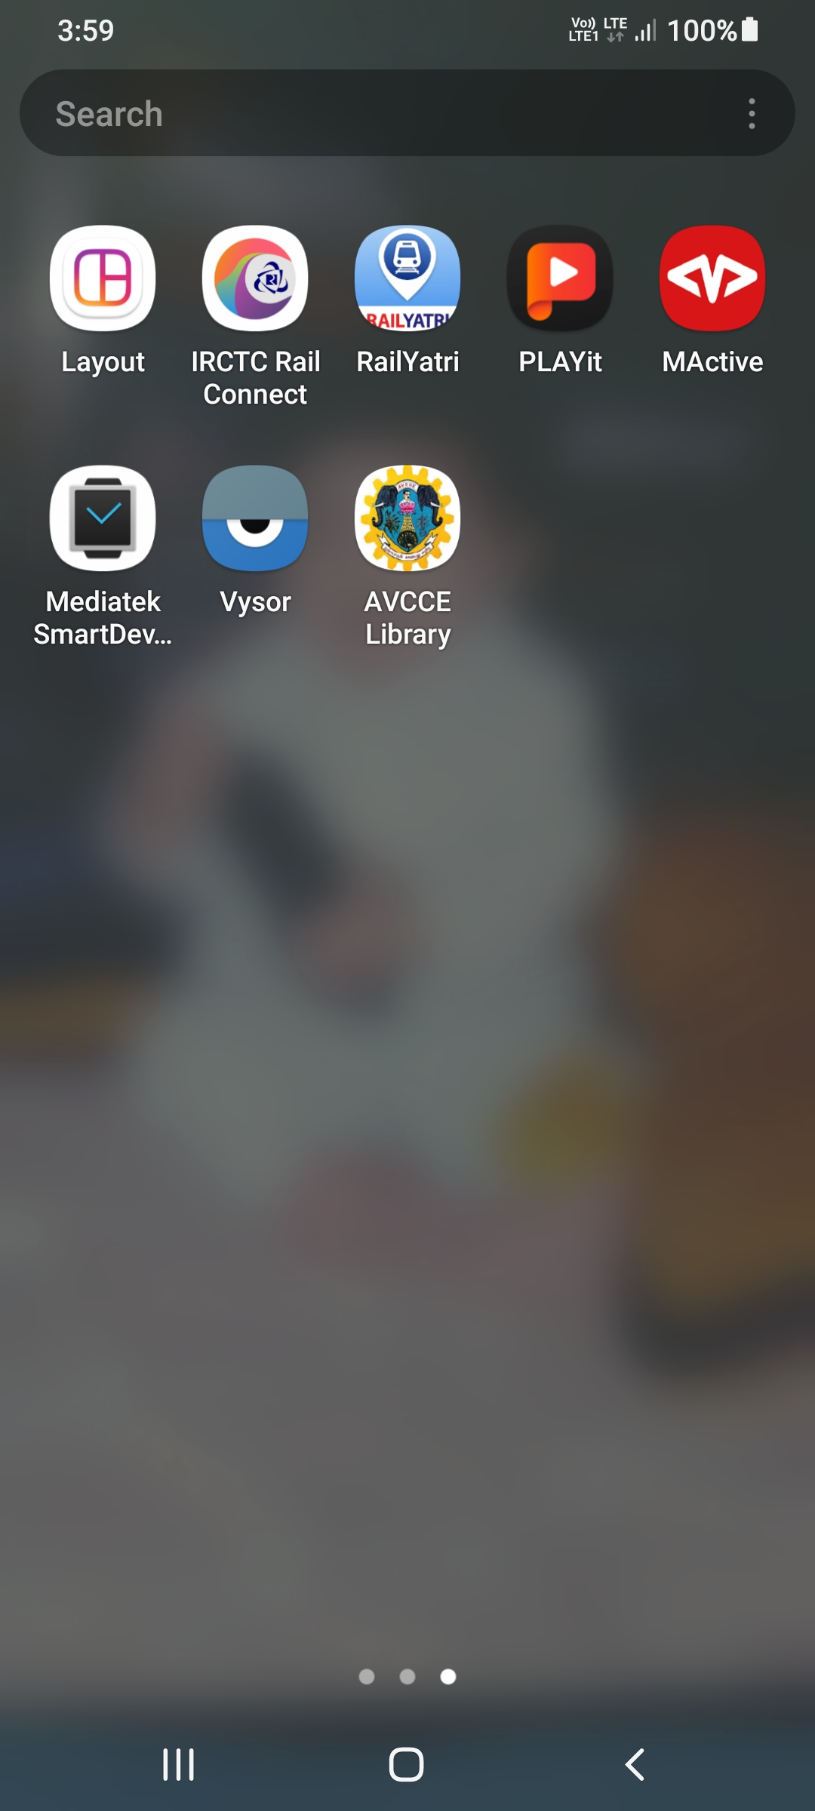

**Fig 8.16 Mobile app loading screen**

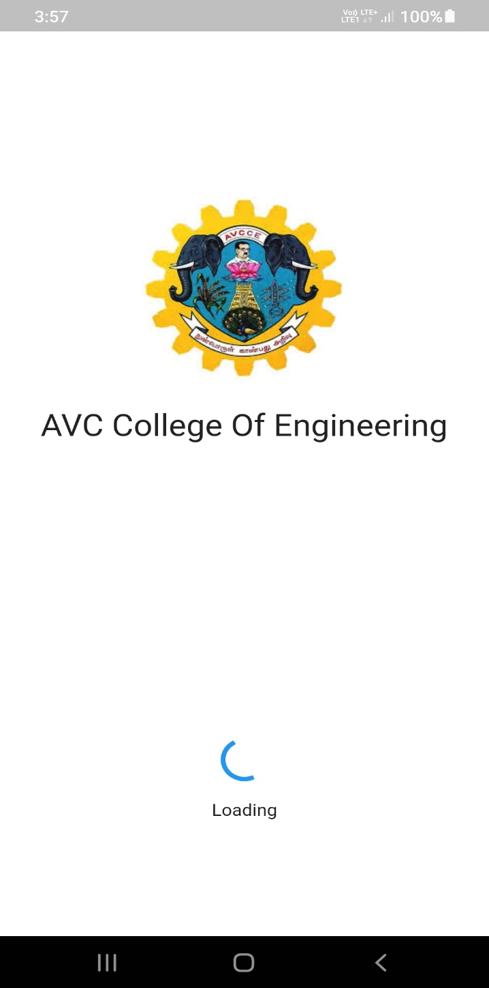

**Fig 8.17 Mobile Application**

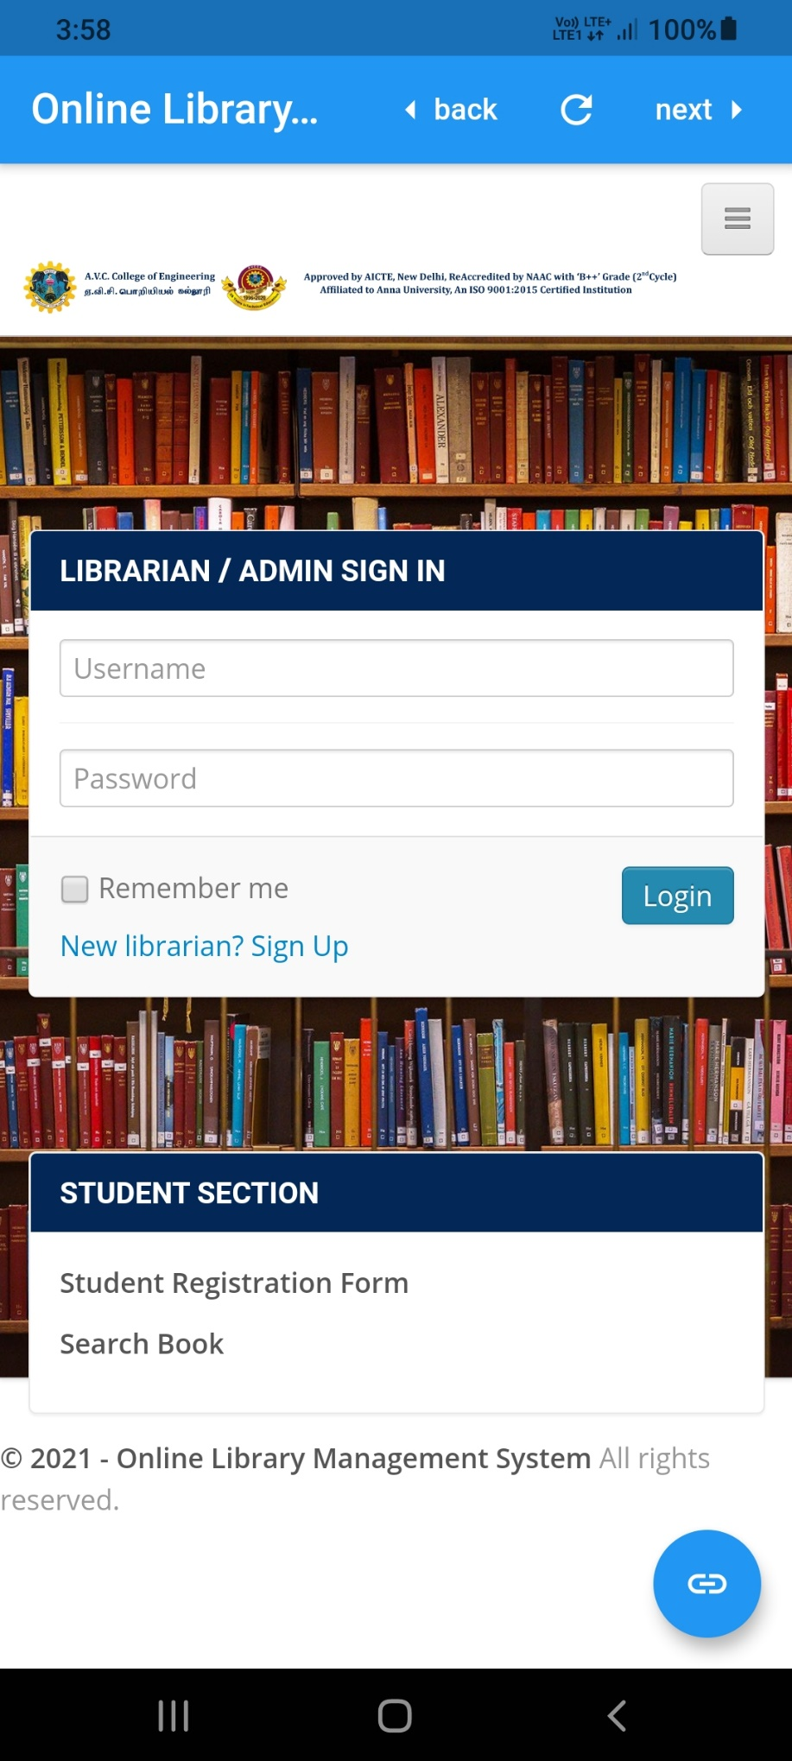

**CHAPTER 9**

**CONCLUSION AND FUTURE ENHANCEMENT**

**9.1 CONCLUSION**

After we have completed the project, we are sure the problems in the existing system would overcome. The “ONLINE LIBRARY MANAGEMENT SYSTEM” process made computerized to reduce human errors and to increase the efficiency. The main focus of this project is to lessen human efforts. The maintenance of the records is made efficient; all the records are through which data can be retrieved easily. The Books and Students are given a particular unique id no. So that they can be accessed correctly and without errors. Our main aim of the project is to get the correct information about a particular student and books available in the library, it is expected that this project will go a long way in satisfying user’s requirements. The computerization of the Library Management will not only improve the efficiency but will also reduce human stress thereby indirectly improving human recourses.

**9.2 FUTURE ENHANCEMENT**

As technology emerges, it is possible to upgrade the system and can be adaptable to the desired system. Based on future security issues, security can be enhanced using emerging technologies. Sub-admin module can be added. Use of more extra classes and modules to shot down the code. Changes made by any user can be monitored. Put on network Auto generates forms for every user when they create a user/ member. Many users can login at the same time. More control by the administrator. Make an online chat facility

**REFERENCES**

[1] Y. A. Anita Gade, Development of library management robotic system, International Conference on Data Management, Analytics and Innovation,2017

[2] H. S. Muhammad Ramadhan Fithian, Muamaroh, Developing a QR code-based library management with case study of private school in Surakarta

city Indonesia, 2018

[3] N. S. K. S. N. T. M. N. I. Md. Mahmood Karim, Ashratuz Zavin, A proposed multi-channel system for public libraries in bangladesh, ICAEE,2017

[4] J. F. Z. Chang Ji Wen, the university library management system based on radio frequency identification jinn,

[5] A. D. Liwen Liu, Management of an academic e-library project, International Conference on Information Management, Innovation Management and Industrial Engineering, vol. 54(8), pp. 62–71, 2011

[6] Y. X. Qu, Research of knowledge management on the university library for subject user, 2011

[7] L. G. X. D. Z. Liu, Knowledge management-oriented architecture design of military equipment digital library, 2008

[8] Y. Z. Jiahui Jiang, Customer-oriented library services for Chinese higher education, 2009

[9] Z. Y. Shao tang Liu, Study on the framing of knowledge management for college library management, International Asia Symposium on Intelligent Interaction and Affective Computing, vol. 21, pp. 613–641,

[10] SHENLi-zhen, Research on hierarchical storage of digital library based on the information life-cycle management, 2010